

Specification

for

Manual Alerts Refresh (5.1 - Marfa)

Trent Miskelly

November 7, 2007



Proprietary and Confidential to BBS Technologies, Inc.

© 2006 BBS Technologies, Inc.; all rights reserved.

Revision history:
When? | Who? | What?
11/2/07 | Trent Miskelly | First Draft

Table of Contents
1. Revision history: ii
2. Table of Contents iii
3. Requirements 1
3.1. Overview/Purpose 1
3.1.1. Related Customer Requests 1
3.2. Target Users 1
3.3. Feature/Function Market Requirements 1
3.3.1. Required Functions 1
3.3.2. Non-Supported Functions 1
3.4. FAQ 1
3.5. Open Issues 2
4. Functional Design 2
4.1. User Interfaces 2
4.1.1. Refreshing alerts from the Server Tree 2
4.1.2. Refreshing alerts from the Server Overview 3
4.2. Installation and Upgrade 3
4.3. Permissions and other Required Configuration 3
4.4. Licensing Issues 3
4.5. Dependencies 4
4.5.1. Dependencies on Idera Software 4
4.5.2. Third-Party Software Required on the Customer Machine 4
4.5.3. Third-Party Software Required Internally 4
5. Internal Design 4
5.1. Architecture 4
5.1.1. Collection Service Changes 4
5.1.2. Management Service Changes 4
5.1.3. Desktop Client Changes 5
5.2. Installation Issues 5
5.3. Schedule 5
5.3.1. Work Breakdown and Sizings 5
5.3.2. Areas of Risk 5
6. Quality Assurance Considerations 6
6.1.1. Overview 6
6.1.2. Developer-Created Unit Tests 6
7. Documentation Considerations 6
8. Bibliography 6

Requirements

Overview/Purpose
Much of the Desktop Client is designed to display alerts from the most recent scheduled collection. Generally this is what is expected. However, because most of the server specific views show primarily real-time data, a disconnect between the last known alert state and the current state can/will often occur. For example, the Server Tree shows the state of monitored SQL Servers based on the last scheduled collection, but the Server Summary view shows controls that are colored according to the real-time data points collected (i.e., a Critical CPU Usage % alert may be raised while the control in the Server Summary view may indicate that CPU Usage % is OK). This has caused some confusion for our customers.
Since the nature of our system design is to offer both historical and real-time data, coming up with a conclusive resolution is a bit of a conundrum. So, to help address synchronization issues when they arise, we’ll introduce a new manual alerts refresh option that can be performed by users if synchronization issues are noticed. This won’t completely alleviate the problem, but it will help users get a current update on alerts when so desired.

Related Customer Requests

Target Users
This feature will be valuable to all of our users. We have not had that many complain about these synchronization issues, but we should go ahead a nip it in the bud before it becomes a larger problem.

Feature/Function Market Requirements

Required Functions
The primary requirement is to offer the option to manually refresh alerts for specific servers. This option will be on a case-by-case basis, meaning it can only be performed on a single server at any given time.

Non-Supported Functions
Users will NOT be able to perform manual alert refreshes on groups of servers. This operation can only be performed on a single server. Performing group refreshes could cause unknown performance problems within the SQLdm system that aren’t necessary to address within the scope of this feature.

FAQ

Open Issues
- Should we put a time limit on how often a manual refresh can be performed for a given server? At this point, we don’t know the impact of this, so it’s going to be hard to answer this question until we’re further in to the implementation.

Functional Design

User Interfaces

Refreshing alerts from the Server Tree
Users can refresh alerts for a specific monitored SQL Server from the Server Tree at any time. This option is already available via the context menu for a server as depicted in the screenshot below; the functionality of the existing option will be extended to force a manual refresh of alerts.

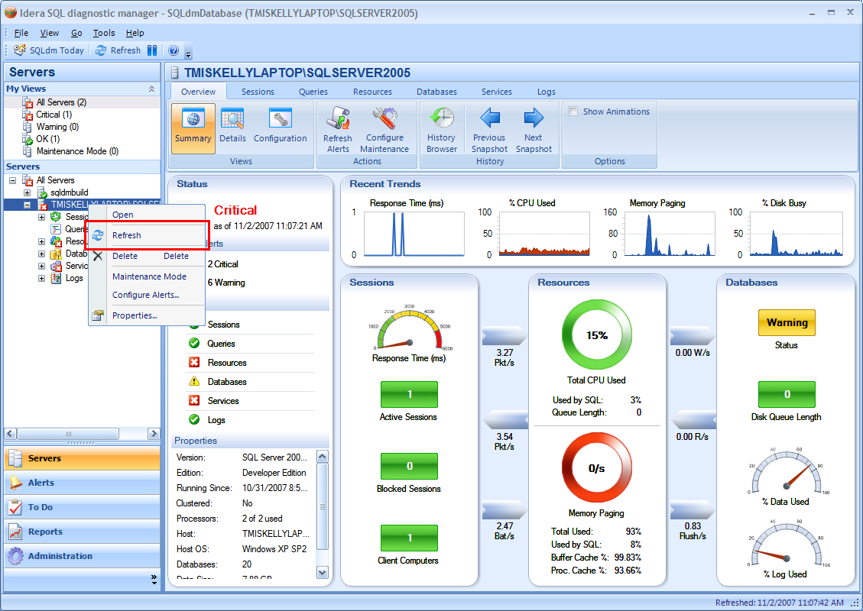
Server Tree Alerts Refresh Context Menu Option

When the Refresh context menu option is selected, a message box will be presented to the user indicating the implications of the action. If the user chooses to continue, a request will be sent to the Management Service > Collection Service that will force a manual refresh of the selected monitored SQL Server. When the refresh is complete, the instance and area state icons will be updated, as well as their associated tooltips.
NOTE: If a manual refresh is in progress for the selected instance, this option will be disabled until the active refresh completes.

Installation and Upgrade
There are no installation or upgrade requirements for this feature.

Permissions and other Required Configuration
Since the refresh request will be sent through the Management Service, no additional permissions or configuration will be required.

Licensing Issues
There are no additional license requirements for this feature.

Dependencies

Dependencies on Idera Software
There are no additional Idera software components required for this feature.

Third-Party Software Required on the Customer Machine
There is no additional third-party software required to deploy for this feature.

Third-Party Software Required Internally
There is no additional internal third-party software required for this feature.

Internal Design

Architecture

Collection Service Changes
The existing scheduled collection will be modified to allow for manual executions. For the most part, this should be a pretty seamless change, but logic will be put into place that will prevent a manual refresh from executing if a scheduled refresh is already in progress, and vice versa.
An API will be added to support a manual refresh and will wait until the refresh completes. This API will be called by the Management Service.

Management Service Changes
The Management Service will call into the Collection Service to request a manual refresh for a specific instance. If an error is returned from the Collection Service, this error will be propagated. Otherwise, the Management Service will process the returned as it would any other scheduled collection. Data storage and alert processing will be performed as a logical unit of work, whereas notification processing will still occur in a separate thread. The primary reason for this separation is that the purpose of this feature is to provide updated alerts in the Desktop Client; notifications are considered a separate, side-effect of a manual refresh and not the primary focus. A new state graph is generated for the instance once alert processing is complete and returned. This state graph will replace the one currently stored in the Management Service cache.
The Management Service will expose an API that the Desktop Client will call to perform a manual refresh. This API will wait until the new metrics are stored and alerts are completely processed and stored.

Desktop Client Changes
The Desktop Client will expose the ability to manually refresh alerts from the Server Tree context menu. This option will call the API exposed by the Management Service to perform server specific alert refreshes.
The call to the Management Service will wait until the manual refresh completes. If a failure occurs, an appropriate error message will be presented to the user including the exception details of the error. If the refresh is successful, a new state graph will be returned for the target instance. This state graph will replace the current one maintained by the background refresh, and the state icons, control colors and tooltips will be updated accordingly.

Installation Issues
There are no additional installation requirements for this feature.

Schedule

Work Breakdown and Sizings

Component | Who | Sizing
Collection Service – Modify scheduled collection to allow for manual collection | Kurt | 2
Management Service – Provide API for manual refresh | Kurt | 1
Desktop Client – Implement manual alerts refresh from Server Tree | Trent | 3
Unit and Integration Testing | Trent | 2
Total |  | 8

Areas of Risk
The following areas of risk should be considered for this feature:
- Since this feature effectively fires an off schedule manual collection and alert processing, we need to make sure this doesn’t degrade performance for normal scheduled collection. Until the feature is implemented, it’ll difficult to know the impact. A contingency plan would be to put a governor in place to limit how often a manual refresh could be performed for a given server. RISK: High

Quality Assurance Considerations

Overview
The follow issues should be considered by QA for this feature:

- Since we will be performing out of scheduled collection and alert processing by the Collection Service, QA should test that process thoroughly. IMPACT: Medium
- Since we won’t be placing a governor on how often this option can be executed. We should perform testing to make sure we don’t run into trouble performing this action rapidly. IMPACT: Medium

Developer-Created Unit Tests
Developer testing will be performed maually for this feature. We will try to automate firing rapid back-to-back refreshes in the collection service as part of this testing.

Documentation Considerations
Since this is a new feature, it should be fully documented, with possible consideration for a release note since it’s replacing existing functionality in the Server Tree. The User Interfaces section outlines most of what documentation should be aware of.

Bibliography

